# **CAMPUS MOBILE APPLICATION**

By Chong Wei Shen AKA LaggingNinja

In this part, we will show our program screenshots, explanation on how it works and the strength and weaknesses.

**Login/Signup:**

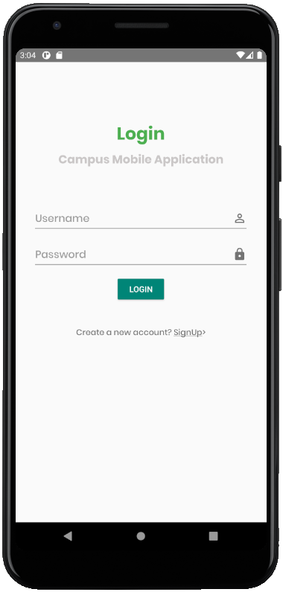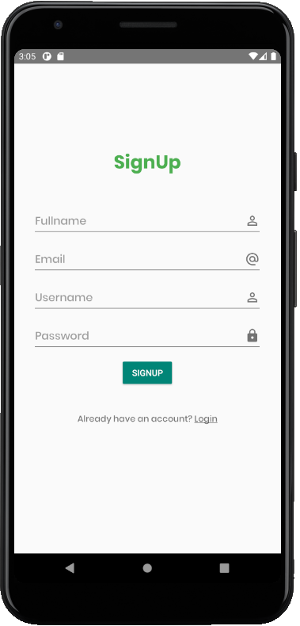

At the start of the program, user will be asked to login. If they do not have an account, they can click on Sign Up to sign up a new account. Both of these are connected to MySQL database.



If the user leaves out any blank while logging in or signing up, a toast saying “All fields required” will pop up to indicate the user.



If the user typed in the wrong username or password while logging in, a toast saying “Username or Password wrong” will also pop up to indicate the user.

**Main user-interface:**

This is the main user-interface of Campus Mobile Application. A modern card UI design with six different card buttons and attractive icons. Next, we will show the features Take Attendance, Booking System, Order Food, E-wallet, Campus Map and Feedback.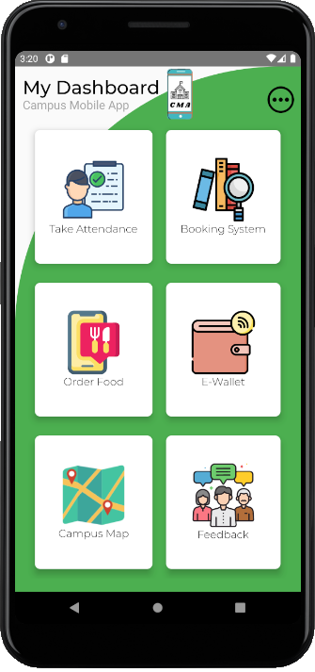

**Take Attendance:**

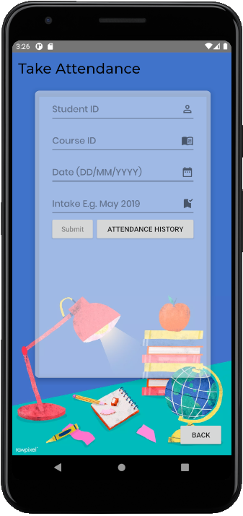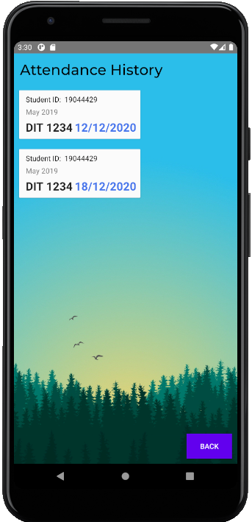

User are given a form to write all the attendance details and submit it to the database. By clicking the “Attendance history” button, the user can view all his submitted attendance history.

The strength of this function is the probability of error occurs are lower. However, there is a crucial weakness, which the student can easily fake their attendance. There is way to improve this feature in the future, and it is mentioned in the **Conclusion and Future Works** part.

**Booking System:**

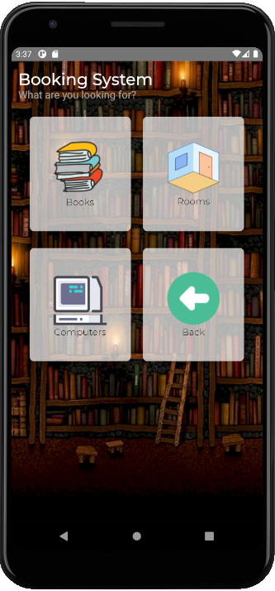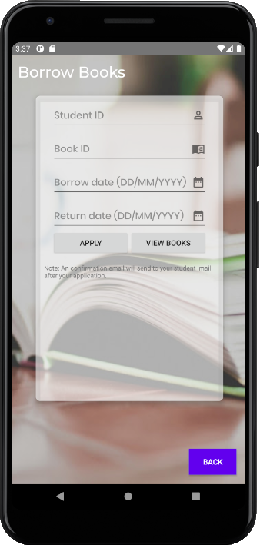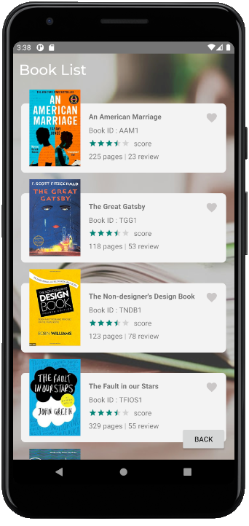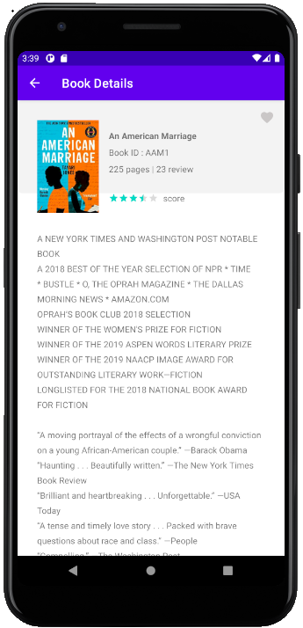

For booking system, it consists of booking books, rooms, and computers. The user-interface is also designed with modern card design. It has very similar function from the attendance system. The user needs to submit an application form, to gain approval from the librarian. By clicking the “View Books” button, a list view of available books will show and it is all clickable with different information.

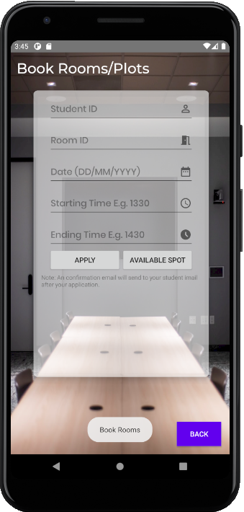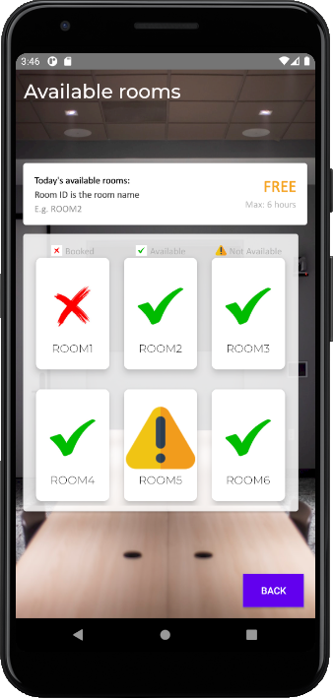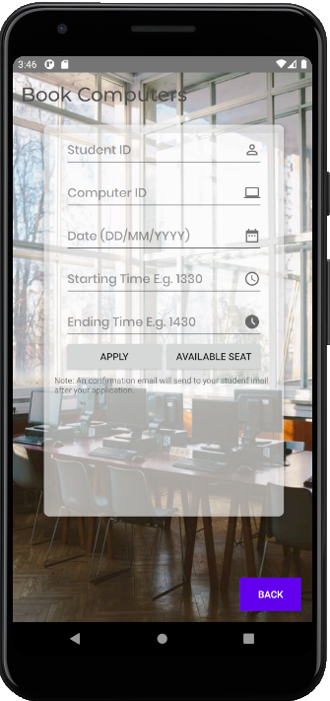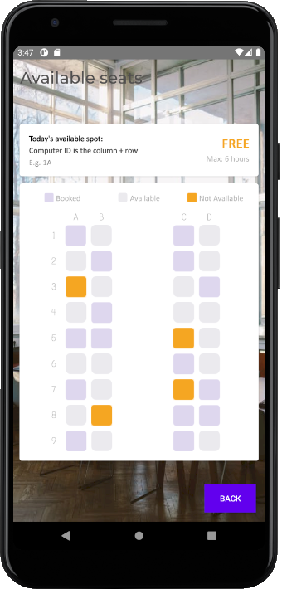

Same goes to booking rooms and booking computers, user will have to submit application form to the database. By clicking “Available Spot”, “Available Seat”, information such as available booked or unavailable rooms, computers will show.



To avoid data error, if the user typed in an unavailable book id, room id or computer id, above toast will pop up to indicate the user.

**Order Food:**

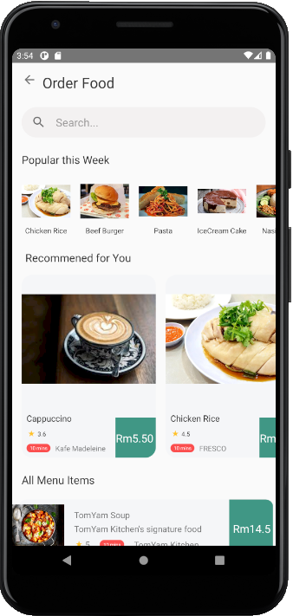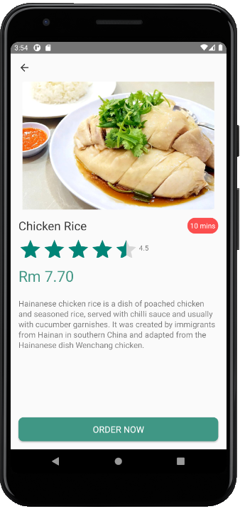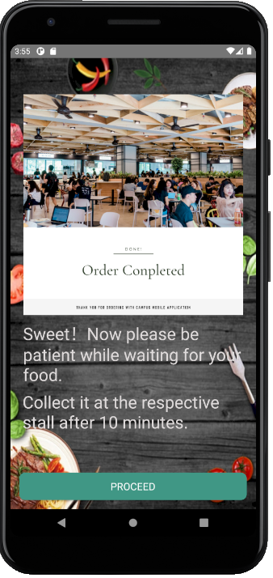

The main interface of order food is simple and tidy. Three list view is used showing the “Popular this Week”, “Recommended for you” and “ALL Menu Items”. Many different foods from different stall to make sure user can pick what their want to eat. Clicking on the food will bring them to the information page, and user can proceed to order the food selected. Order completed page will pop up after the user ordered the food.

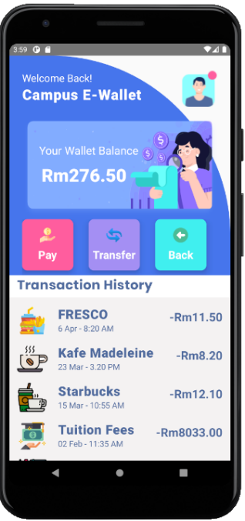**E-wallet:**

This is the interface of e-wallet feature. It is not fully functionable as it is just one of our concepts. In this page, it consists of the wallet balance, pay button, transfer button, back button and all the transaction history.

**Maps:**

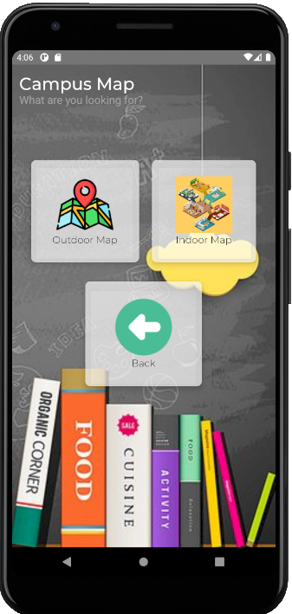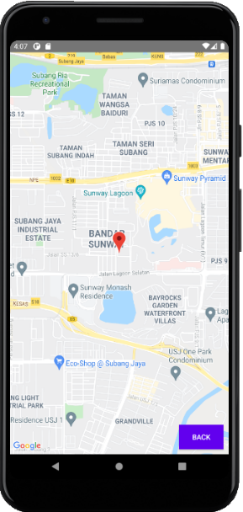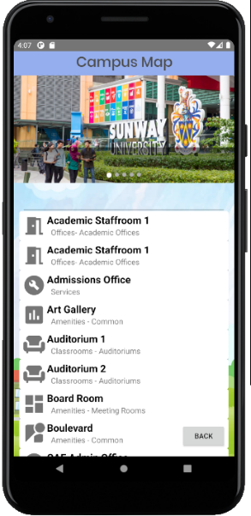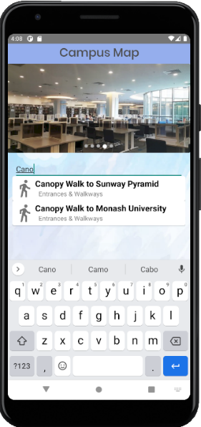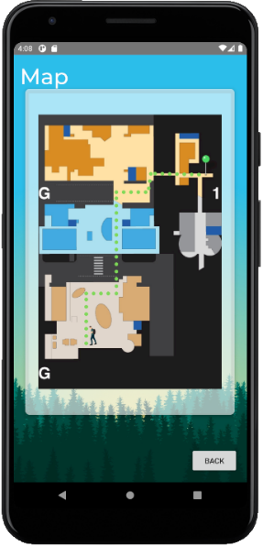

For the map feature, we included the campus map, we use the google map API to show the campus location. Next, in the indoor map function we added a glide image view to the user-interface. Bellow shows a list view that has all the campus location. It is also searchable, above screenshots show when the user clicked ok “Canopy walk to Sunway Pyramid”

**Feedback Form:**

We also included the feedback form feature, which allows user to send us feedback on the Campus Mobile Application.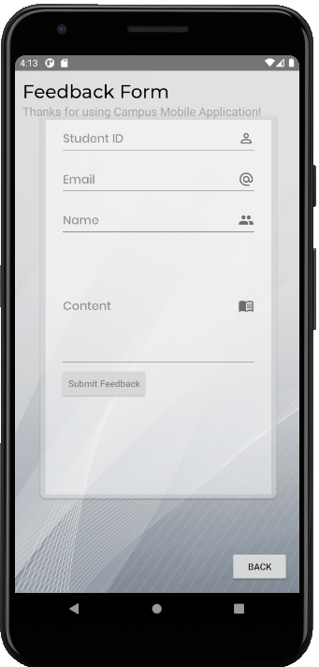

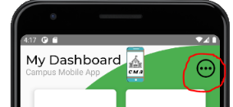**More Campus Info:**

When the user clicks on this button in the main page, it will redirect them to more campus information.

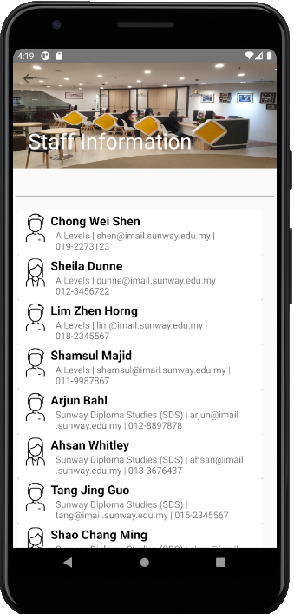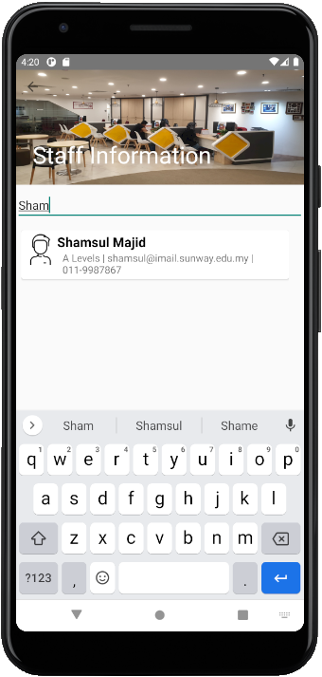

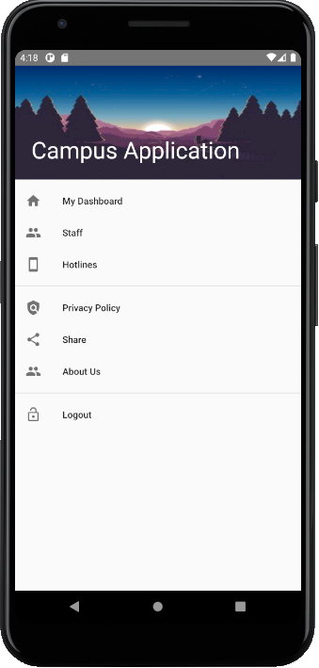

“My Dashboard” button will bring the user back to the main interface, above screenshot shows when user click on “Staff” button. It has a list view of all staff and their respective information. It is also searchable by clicking on the edit text box.

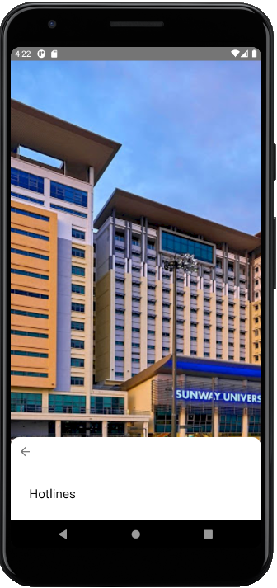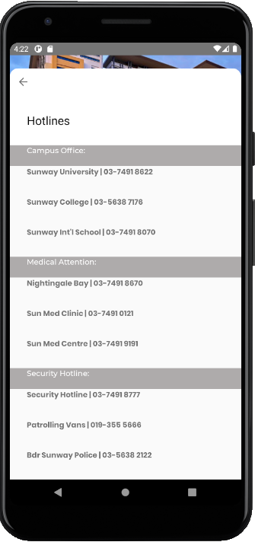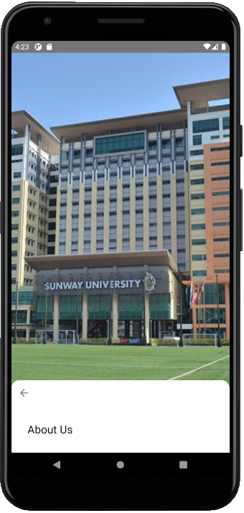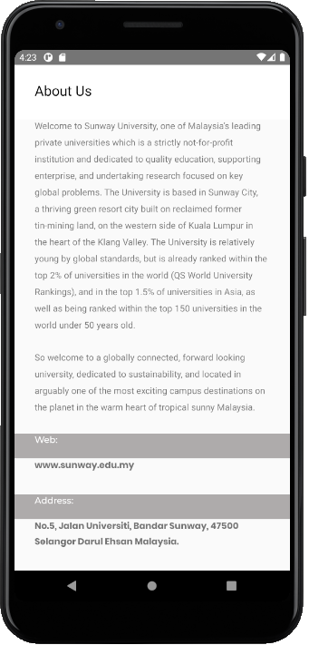

Next, the “Hotlines” and “About Us” button. Both of the interface we added a hover animation to catch user’s attention. When the user scrolls upwards, all the campus information is provided, with better and nicer user interface at the same time.

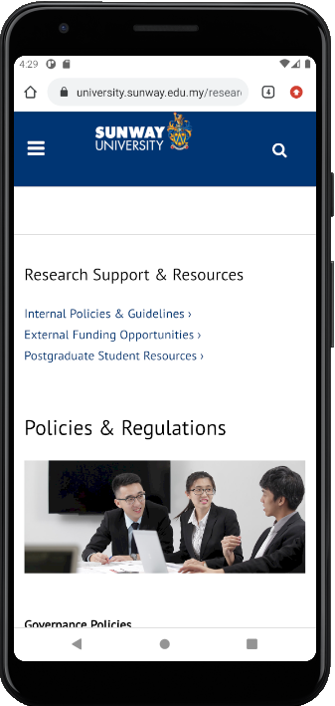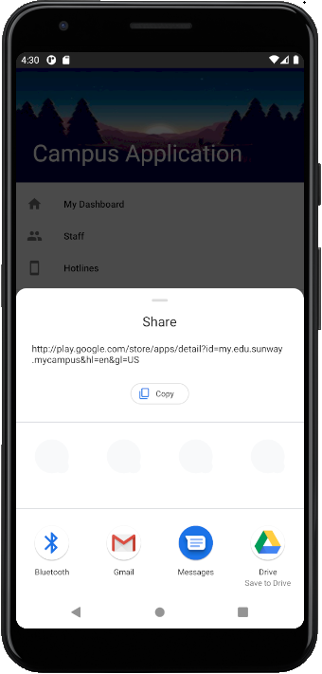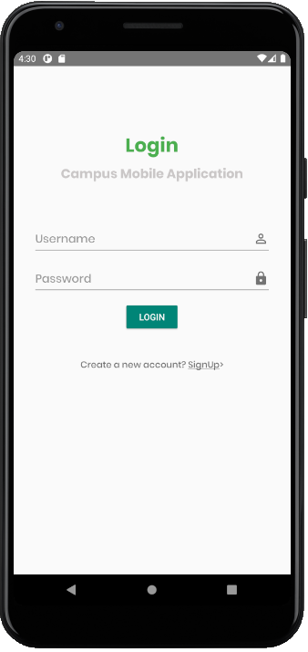

First screenshot shows what happens when the user clicked on “Privacy Policy”. It will redirect them to the official Sunway policies and regulations webpage.

When the user clicks on the “Share” button (Second screenshot), user will be able to share this application with their friends.

Last screenshot shows what happen when the user clicked the “Log Out” button. It will log the user out to the login interface.

**END OF REPORT**